**Дата**: 5.12.2024

**Клас**: 9-А

**Предмет**: англійська мова

**Тема:** Співбесіда .

**Мета:** : формувати навички вживання лексичних одиниць по темі; удосконалювати навички читання, аудіювання й усного монологічного мовлення; розвивати пізнавальні інтереси учнів; виховувати інтерес до самостійного пошуку потрібної інформації, а також загальну культуру учнів.

**Вчитель**: Руда Д.В.

Хід уроку

1.Greeting

Good afternoon, guys! I’m glad to see you. Are you ready to start our lesson? All set?

2. Wаrm up / Listening

Уважно слухати аудіо трек і дати відповідь на питання вчителя <https://www.youtube.com/watch?v=7NP0tX9-cbE> .

3. Speaking

Дати усно відповіді на питання :

1. What’s your favorite thing to do on the playground?
2. Did you have any fun dreams last night?
3. What’s your favorite color and why?
4. Can you tell us about something kind you did yesterday?
5. What’s your favorite animal and why?
6. What’s your favorite book to read before bed?
7. What’s something you’re looking forward to today?
8. What’s your favorite thing about yourself?
9. Can you tell us about a time when you felt really happy?
10. What’s your favorite song to sing or dance to?
11. Did you learn anything new yesterday?
12. Can you show us your best silly face?
13. What’s your favorite thing to have for breakfast?
14. Can you tell us about a time when you helped someone?
15. If you could have any superpower, what would it be?
16. Can you tell us about a place you’d love to visit?
17. What’s your favorite thing to do with your family?
18. Can you share something that makes you feel proud?
19. What’s one thing you want to learn how to do this year?
20. What’s your favorite thing to do with your family on weekends?
21. If you could go on a magical adventure, where would you go and who would you take with you?
22. What’s your favorite outdoor game to play with friends?
23. If you could have any pet in the world, what would it be and what would you name it?

4. Повторення

Повторити слова впр 2 стр 124.

Повторити past perfect. (вправа подана нижче)

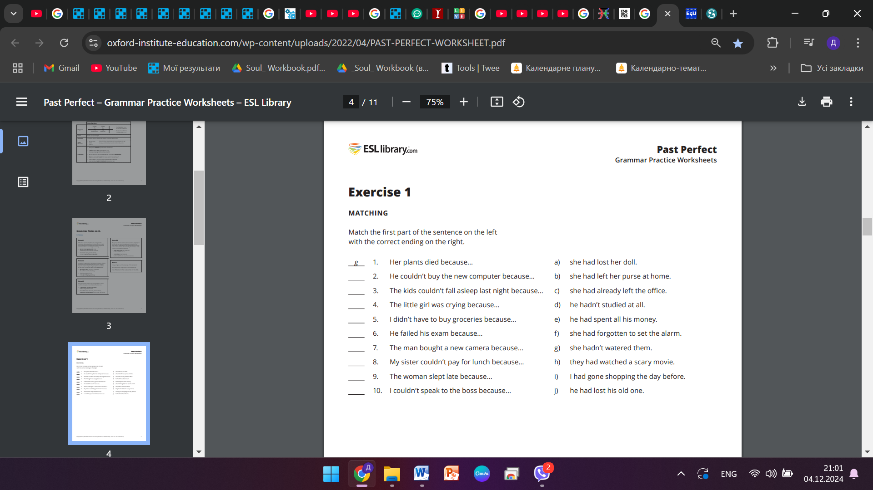

5. Writing

Виконати письмово вправу 6 стр 100-101.

6. Homework

1. Виконати вправу 7 стр 101-102.